Backup
- A backup is a replica/copy of an important data.
- Backup is created to protect data from getting damage or accidentally getting deleted.
- Backups are useful in the situations like:
  - Hardware failure
  - Accidental deletion
  - Malware attack
  - Data corruption
  - Disaster
Core components of backup
- Backup source
  - The original data source that needs to be backed up.
  - This is what you are protecting.
  - Types of sources:
    - Physical servers (bare-metal systems)
    - Virtual machines (Hyper-V, VMWare, KVM)
    - Databases (Oracle, MySQL, SQL Server)
    - Applications
    - Filesystems (NAS, SAN)
    - Cloud backups (Azure Backup, S3 buckets)

- Backup target
  - The destination where backup will be stored.
  - Example:
  - Disk-based backups:
    - Local disks
    - NAS storage
    - SAN storage
  - Tape storage
    - Used for long term archival.
  - Object storage
    - AWS – S3 bucket
    - Azure – Azure BLOB (Binary Large Object) storage

- RTO (Recovery Time Object)
  - How quickly you need to restore the data (i.e., How faster systems must be restored)
  - Ex: RTO 1Hr systems must be operational within 1 hour.
  - Mapping:
    - Critical apps Minutes
    - Business apps Hours
    - Non-Critical Days

- RPO (Recovery Point Object)
  - How much data loss you can afford?
    - Ex: RPO = 15Mins You can lose up to 15mins of data.
    - Ex2: WhatsApp = 24Hrs You can lose up to 24Hrs of data.
  - Mapping:
    - Banking systems Near-zero
    - E-commerce Minutes
    - File servers Hours
Supporting components:
- Backup policy
- Backup method
- Backup software
Types of backups:
- Full backup
  - It basically takes FULL backup of your system/data.
  - It’s the simplest backup type.
  - It is independent backup set.
  - It’s the fastest while restoring.
  - Advantages:
    - Easy to restore
    - Least complex
  - Disadvantages:
    - Takes long time
    - It uses maximum storage
    - It consumes more network bandwidth
- Incremental backup
  - It will backup only since last backup was done.
  - Faster and efficient to backup
  - Slower in restoration.
  - Useful for large enterprises
- Differential backup
  - It’s the backup since last FULL BACKUP.
  - Faster restore
  - More storage
- Synthetic full backup
  - It merges incremental backup to simulate a full backup.
- Mirror backup
  - Taking the backup at the real-time (RAID1 – Mirroring)
- Snapshot backup
  - Capturing the state of a virtual machine in VMWare workstation.
  - In Hyper-V, it’s called “Checkpoint”.
Backup design pattern – “3-2-1 Rule”:
- 3 copies of the data will be created.
  - 1 primary backup
  - 2 backup copies
- 2 different media types for taking backup.
  - Disk drive
  - Tape storage
  - Cloud storage
- 1 copy off-site must be present.
  - Cloud or
  - Remote location

Backup policies
- A backup policy is a rule that helps in:
  - How to create a backup?
  - How to store a backup?
  - How it has to be managed?
- Components of a backup policy:
  - Scope
    - What to back up?
    - File, folder, drive
  - Frequency
    - How frequently you want to take backup?
    - Daily, hourly, weekly, monthly, etc.
  - Retention
    - How long you want to keep the backed-up data?
    - 7 days, 15 days, 30 days, etc.
  - Storage
    - Where you want to take the backup?
    - On-premises, cloud, hybrid
  - Encryption
    - Data must be encrypted.
    - At-rest – when data is stored.
    - In-transit – when data is moving.
    - Or both.
  - Access/authentication
    - Who can manage the data.
  - Compliance
    - To ensure to meet the regulatory needs.
      - HIPAA
      - GDPR
      - PCI-DSS

Types of storages for backup:
- Tape drives
  - Tap drives uses magnetic tapes
  - It’s a low-cost solution
  - It can store data for years without any data loss.
  - It must be handled manually
  - Needs to be protected from physical damage.
- Disk storage
  - We can use
    - HDDs
    - SSDs
    - Disk arrays (NAS & SAN)
  - Faster, easy to monitor.
  - It is costlier than tape drives
  - Hardware failure
  - Data corruption over the time.
- Cloud storage
  - AWS, Azure, GCP…
  - Quickly and easily accessible
  - Quickly and easily scalable
  - No hardware is needed.
  - More data, means more money.
  - Dependent on internet.
Question – how to upload bulk data (say 20TB) from on-prem to cloud?
Solution
- AWS snowball, snow ball edge, snow mobile
- Azure Azure Import & Export service

Backup software and tools:
Windows:
- Using “file history”
- Using system image backup
- Powershell scripts
- Backup to the cloud
- On windows server, install a role “Windows Server Backup”
Linux
- Use CP (copy) command
- Use TAR utility for archiving the data
- Rsync utility
- Shell script
- Use “dd” command
- Use “SCP” (secure copy) command

Enterprise-level backup solutions:
- Veeam backup
  - Standard for virtual, physical and cloud backups
  - It supports multi-cloud/hybrid environment setups
- Commvault
  - Used for on-prem, cloud and SAAS applications
  - Automation and scalability are supported
- Rubix
  - Automation-focused and quick restore
  - Useful in hybrid environments
- Cohesity
  - High automation, instant recovery tool
  - Centralized management for enterprise
- Acronis cyber protect
  - Integrated backup with cybersecurity feature
- Veritas backup
  - Used for new or legacy apps
Open-source backup tools
- FBackup
- Backup PC
- EaseUS to do backup

Backup and recovery procedures:
Backup procedures:
- Policy and planning
  - Defining the scope – what to be backed-up? Data, apps, etc.
  - Backup policy – frequency, retention period, media type and access.
  - Redundancy – apply 3-2-1 rule
- Execution
  - Automation – automate the backup procedure
  - Monitoring – use monitoring tool
  - Security – in-transit or at-rest encryption
- Maintenance
  - Regularly testing backed up data
  - Documentation – detailed document must be maintained.
Recovery procedures:
- Preparation
  - RPO/RTO
  - Prioritization – giving the priority to the critical components first.
- Restoration steps:
  - Detection – identify the data loss
  - Evaluation – scope of the affected data
  - Initialize restore
    - Retrieve backed data
    - Use the appropriate software for the restoration
    - Monitor the restoration process
  - Validation – checking the integrity of the restored data.
- Post-recovery
  - System hardening – apply patches, RCA
  - Testing and feedback – post-incident review

Monitoring
- It is a continuous process of observing the health, performance and usage of a system.
- With monitoring we can collect data like:
  - CPU usage
  - Memory usage
  - Disk usage
  - Uptime
  - Error logs
  - Network logs
  - Application logs
  - Temperature of the hardware device
  - Services
  - Alerts
  - RCS
Advantages of monitoring
- Easy alerts
- Performance optimization
- Improved security
- Audit and compliance
- Reduced downtime
Disadvantages of monitoring
- Complex to setup
- Cost of the tool
- Privacy risk
Working of a monitoring tool:
- Data collection
- The monitoring tool collects data from different sources:
  - Agent-based methods – a software/agent is required to collect the data.
  - Agentless method – system uses SSH, WMI or API to collect information
  - Cloud APIs – for AWS, Azure, GCP, etc…
- Data transmission
- Then the collected data is sent to the monitoring server at regular intervals (few minutes, hours, days)
- It uses various protocols to share the data like HTTP, HTTPS, TCP, UDP.
- Data processing
- The monitoring tool then processes the incoming data.
- Like:
  - Check the CPU threshold.
  - Applies rules to the increase threshold.
  - Stores the data in the tool’s database.
- Alerts and notifications
- Is an issue is detected then monitoring tool will trigger alert using:
  - Emails
  - SMS
  - Teams message app

- Visualization and reporting
- Monitoring tool will show the report in real-time.
- By using:
  - Graphs
  - Charts
  - Heatmaps
  - Logs
  - Custom dashboards (Grafana, Kibana)
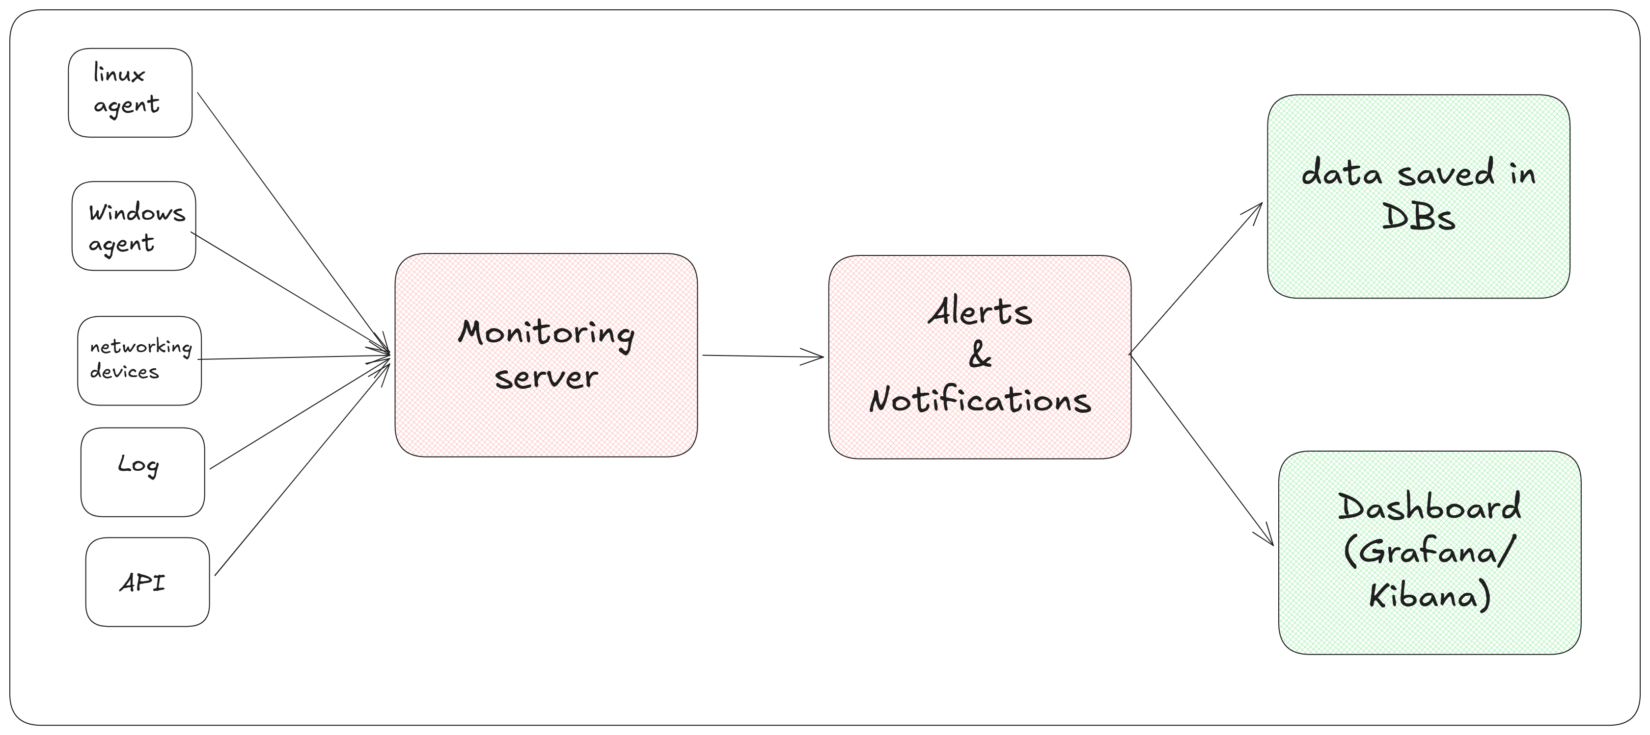
List of monitoring tools:
- Free/Open-source tools
  - Nagios Core – CLI tool with customizations
  - Zabbix – open-source tool with dashboards
  - Prometheus – a free tool integrated with Grafana
  - LibreNMS – Networking-focused tool for networking devices
  - Sensu core – for monitoring pipelines in Devops
- Enterprise/Paid tools
  - Nagios XI – a production level web-based tool with dashboard
  - Zabbix enterprise support – enterprise-level monitoring tool with dashboard.
  - SolarWinds network performance monitoring (NPM) – used for network monitoring.
  - DataDog – full stack cloud monitoring tool
  - New Relic – enterprise level monitoring tool
  - Splunk – real-time metrics logs and tracking tool
- Cloud Monitoring tools
  - Amazon CloudWatch – monitoring EC2, services and logs
  - Azure Monitor – monitoring solution for resources in azure
  - Google cloud operations – Native monitoring tool for google resources
  - Grafana Cloud – hosted with Prometheus and Loki
  - ELK – ElasticSearch, Logstash, Kibana
  - Sentry – for frontend and backend code
Nagios
- Nagios is a powerful monitoring tool.
- It helps in monitoring:
  - Linux systems
  - Windows systems
  - Network
  - Applications
  - Services
  - Disk drives
  - Processes
  - Hardware temperature
  - State of the system
- Nagios is available in 2 modes:
  - Nagios Core
    - It’s a free tool that works only on CLI.
    - It is highly customizable
  - Nagios XI
    - It is free for 60 days only.
    - It’s a fully GUI interface that manages all using web browser.
Nagios architecture:
- Nagios Core
  - It’s the central engine to execute the commands
- Plug-ins
  - Scripts to work with Nagios, like:
    - Check_ping
    - Check_disk
- NRPE (Nagios Remote Plugin Executor)
  - This tool helps in monitoring linux/UNIX based systems.
- NSCP (NS Client++)
  - This tool helps in monitoring Windows based system.
  - You need to download and install NSCP on windows (via manually or scripts)
- Web interface
  - GUI to visualize the reports, logs, notifications
- Event handler
  - Scripts that triggered when alert occurs.
- Notification system
  - Sends alerts via email, SMS, calls, push notifications.
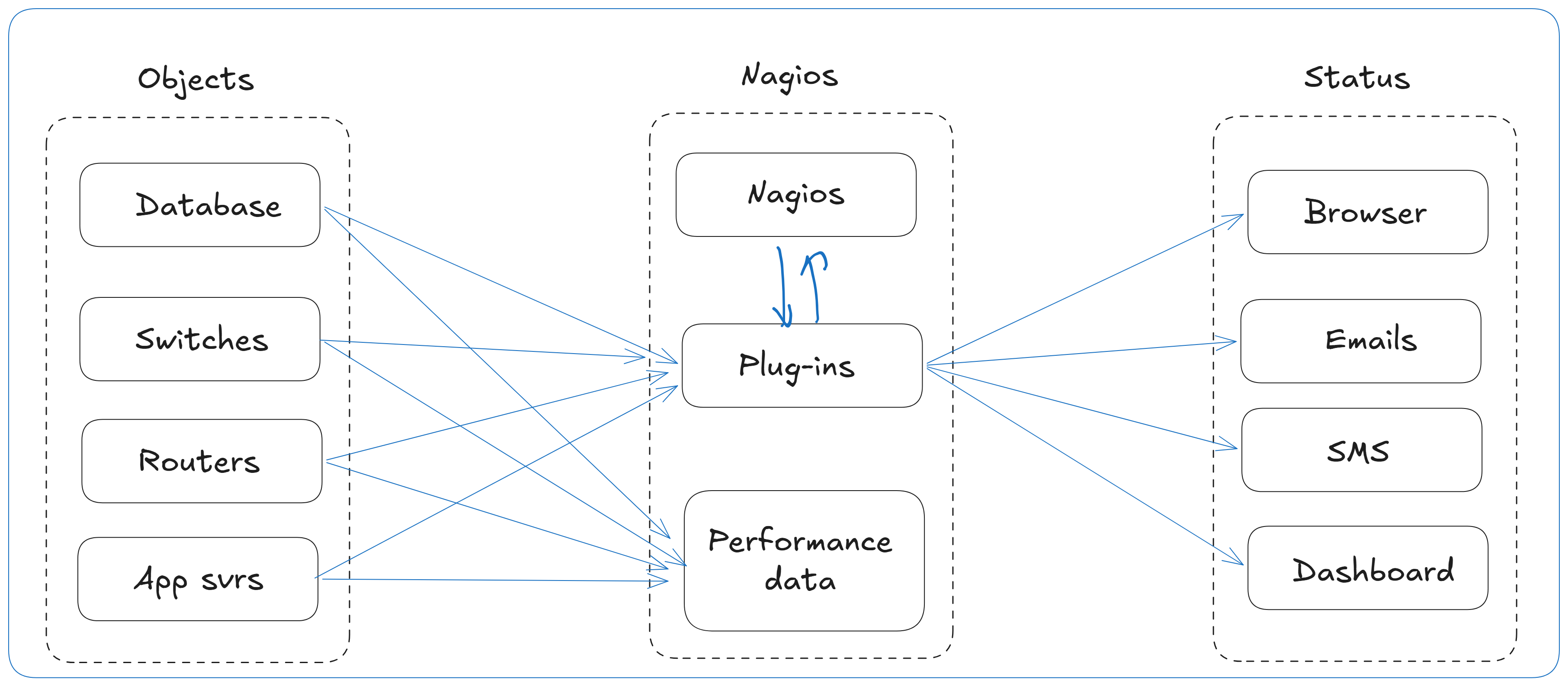
Prometheus
- Download link: https://prometheus.io/download
- Download the windows-amd64 setup: https://github.com/prometheus/prometheus/releases/download/v3.11.1/prometheus-3.11.1.windows-amd64.zip
- Create a new folder C:\Prometheus and extract all files in it.
- After extraction, you will have below files:
  - C:\Prometheus\prometheus.exe
  - C:\Prometheus\promtool.exe
  - C:\Prometheus\prometheus.yml
  - Configure the basic Prometheus settings.
    - Open “C:\Prometheus\prometheus.yml” file and make below changes.
- cd c:\prometheus
- prometheus.exe --config.file=prometheus.yml
- go to browser & type http://192.168.10.10:9090
you need to install windows_exporter on all windows server machines
- DC
- Member01
- Member02
run cmd as administrator

cd Downloads

msiexec /i windows_exporte....msi ENABLED_COLLECTORS="cpu,cs,logical_disk,memory,net,os,service,system" LISTEN_PORT="9182"

and then just hit install ... finish

on web browser run below
http://localhost:9182/metrics

